Analytics 102 Webinar Summary

Creating a customized Dashboard
- Login into Google Analytics
- Click on the “Reporting Tab”
- On the left hand side there is a tab labeled “Dashboards” click on it
- You will have 2 options (private and new dashboard), click on the “New Dashboard” option
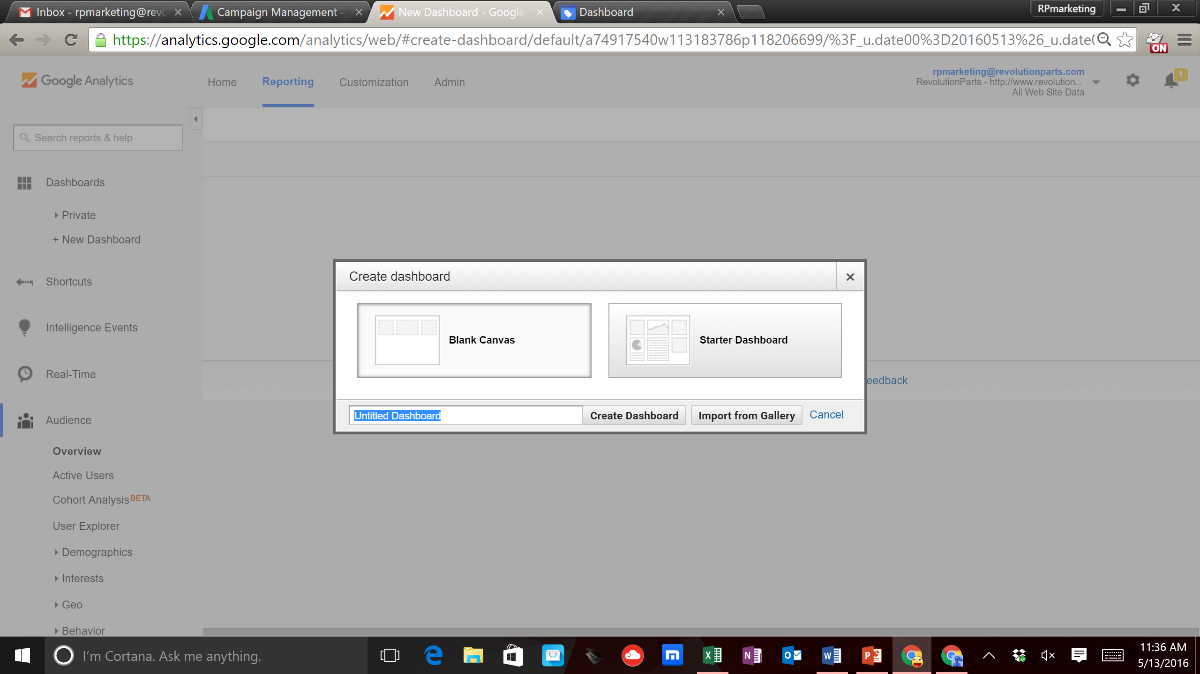
- Name your Dashboard something like “Key Metrics”
- Then click on “Create Dashboard”
- Now you will create your first widget or metric that you want to measure
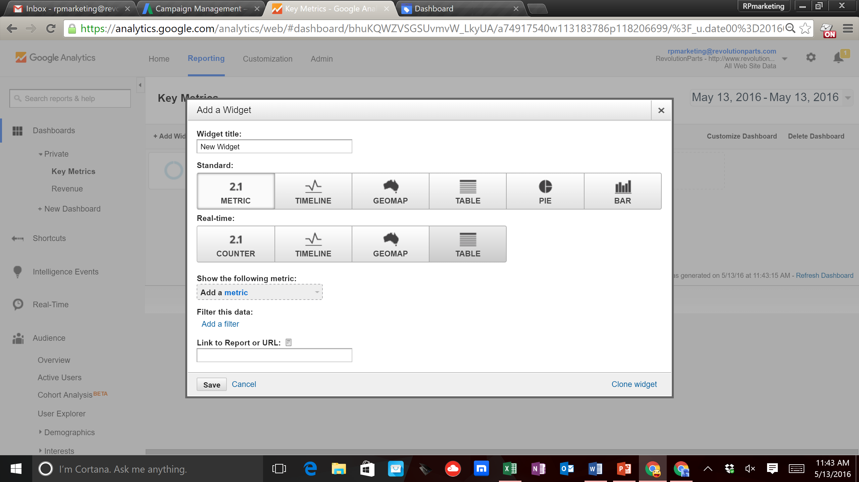
- First name your widget (metric) that you want to include on your dashboard. Some things to include are Revenue, Transactions (orders placed), ROAS (return on ad spend), etc
- Then select how you want to view these metrics (timeline, table, pie chart, etc)
- Next select the metric that matches your widget title. You can type in the search feature.
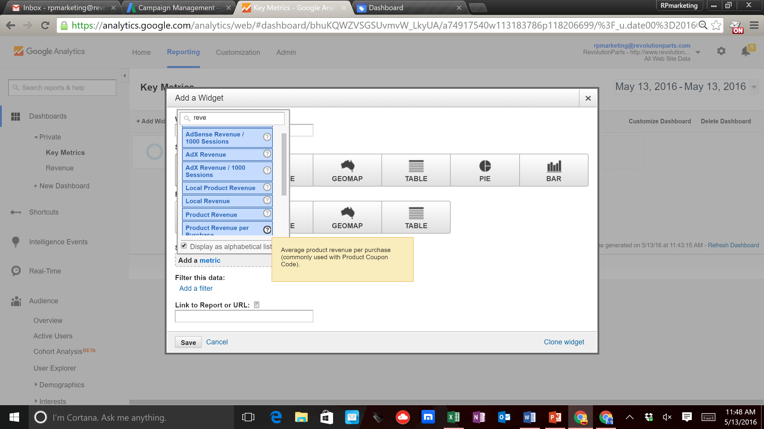
- Once you select the metric hit the “Save” button
- Add as many metrics as you like and you can organize the order by dragging the different widgets around the page.

Ecommerce Tracking Set-Up
- Now you will set up your E-commerce features, which will allow you to track your sales and the different sources where they are coming from. Now go to the ‘View’ column and click on the ‘Ecommerce Settings’
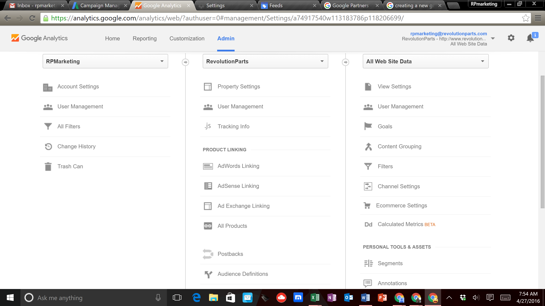

- In the ‘Enable Ecommerce’ section you will ‘Turn On’ both of the features.
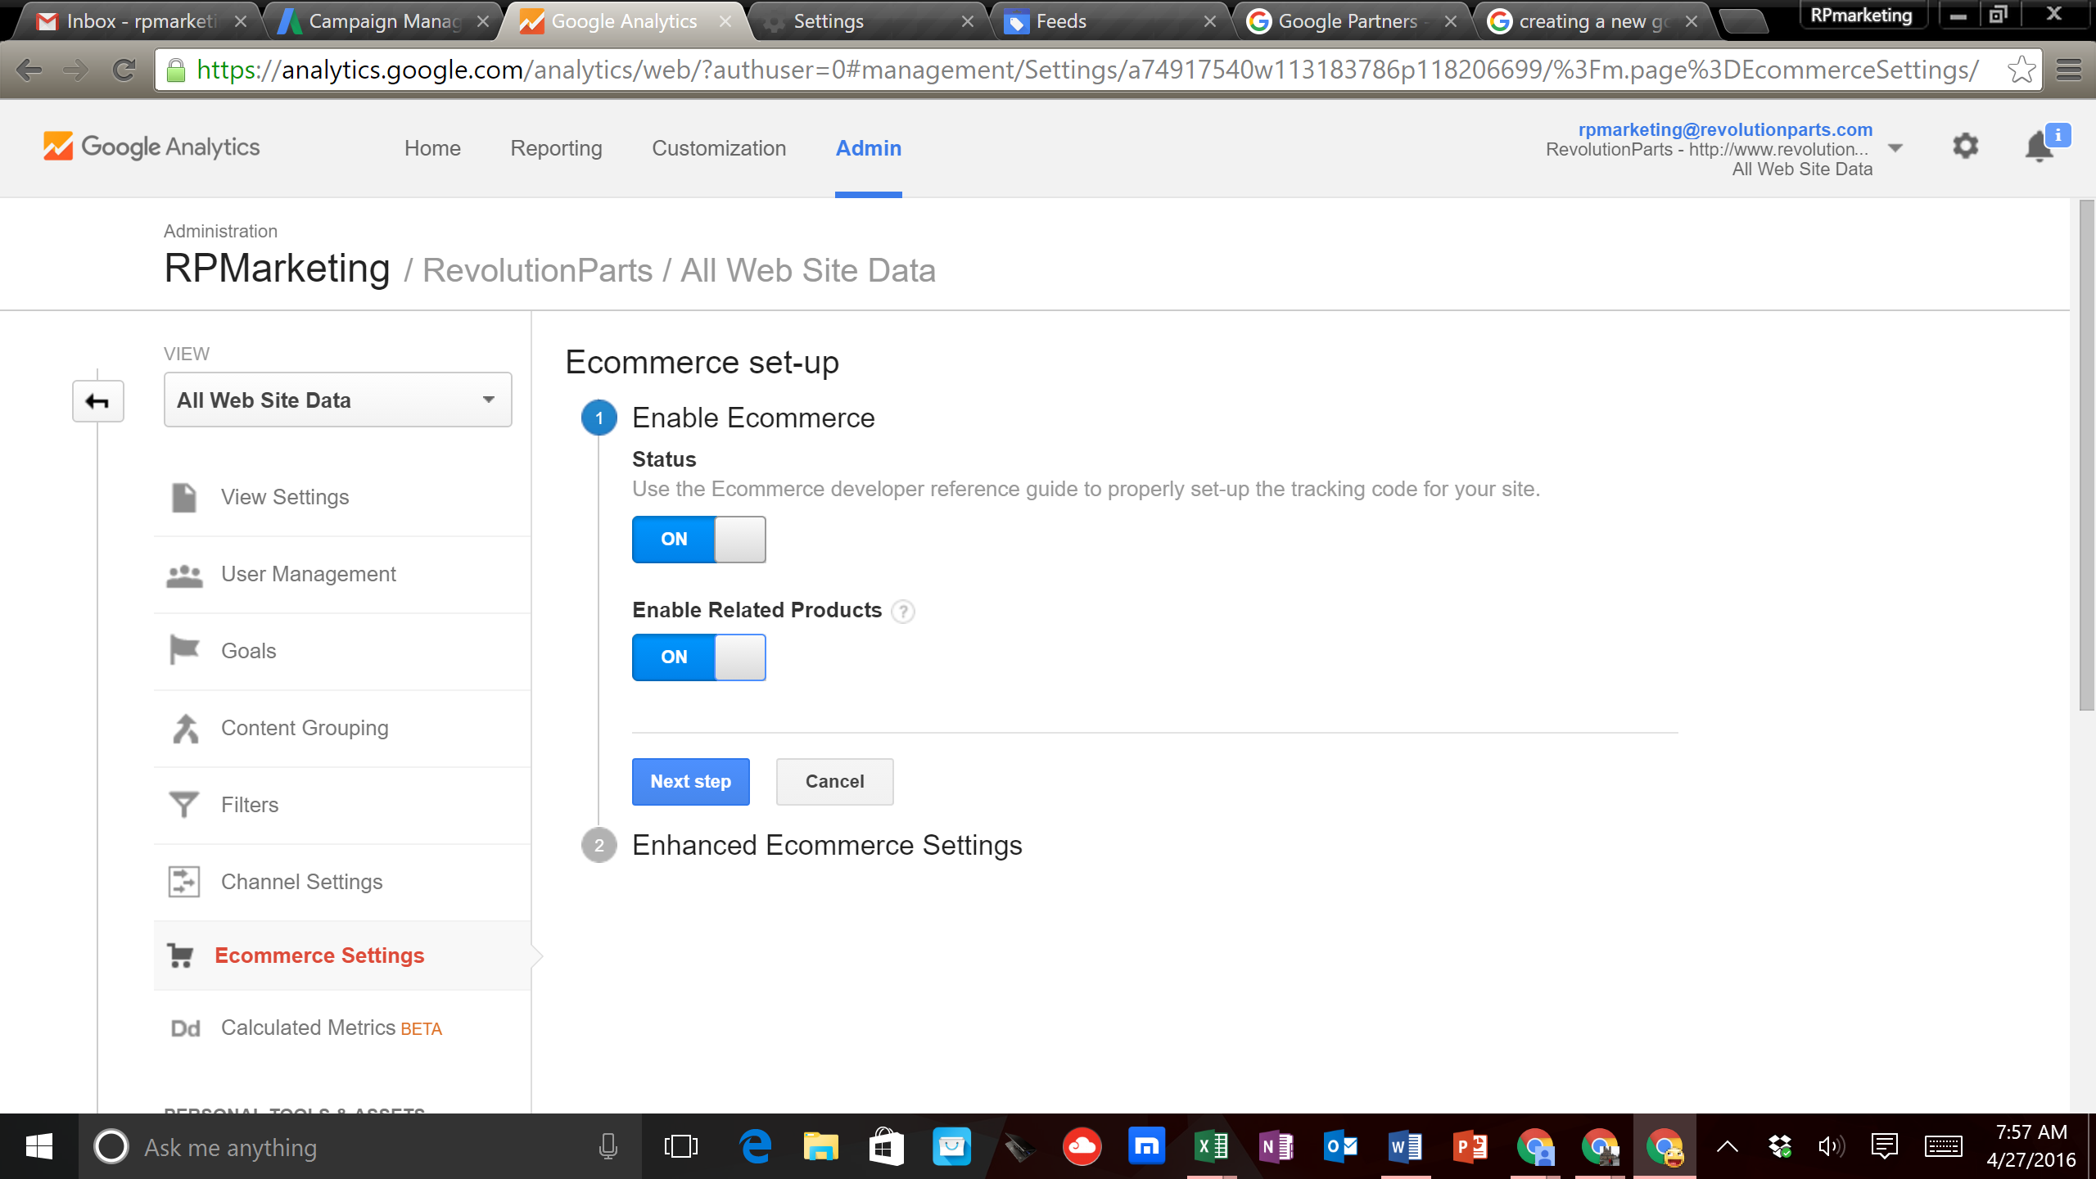

- Then click ‘Next Step’
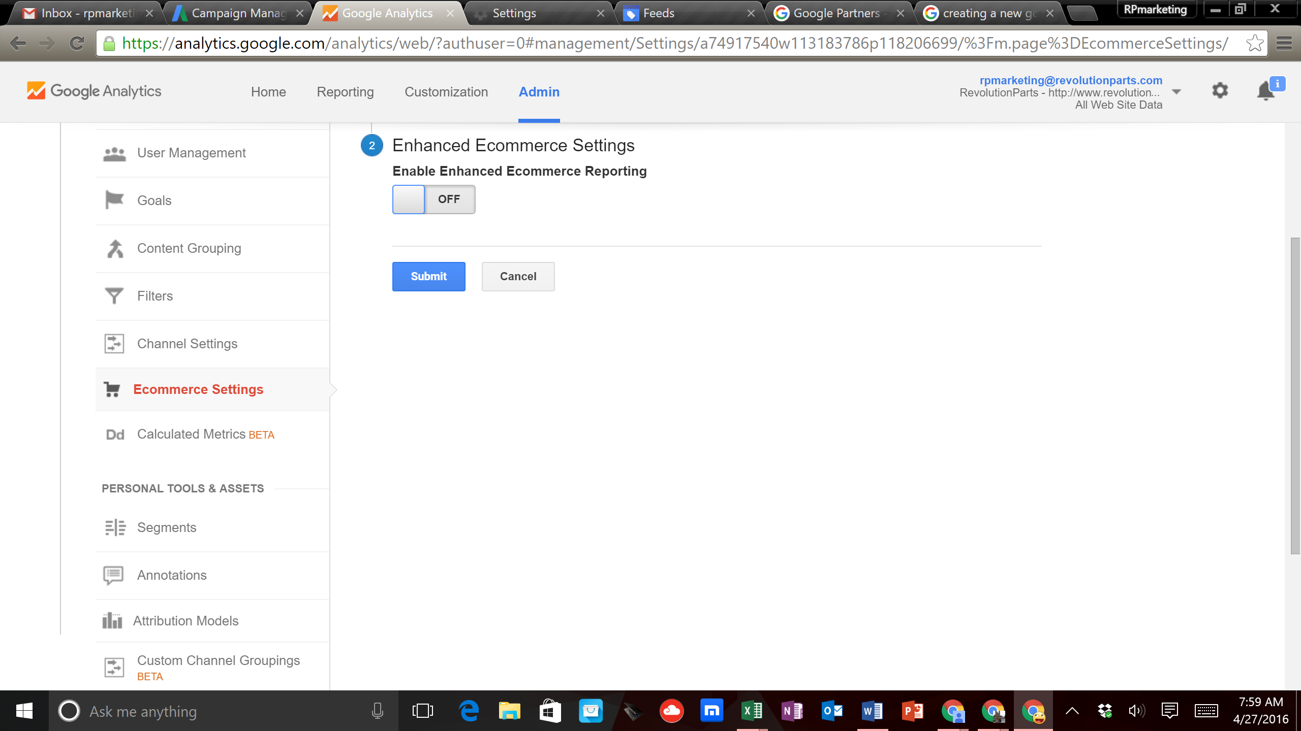

- In the ‘Enhanced Ecommerce Settings’ you will now ‘Turn On’ these settings. Then you will click on ‘Submit’
- Now your Ecommerce tracking is set up. This is VITAL to tracking your transactions and revenue in Google Analytics.
Linking Google Analytics and Google AdWords
1. Go to Google AdWords https://www.google.com/adwords/ and click ‘Sign In’ on the upper right hand side of the screen.
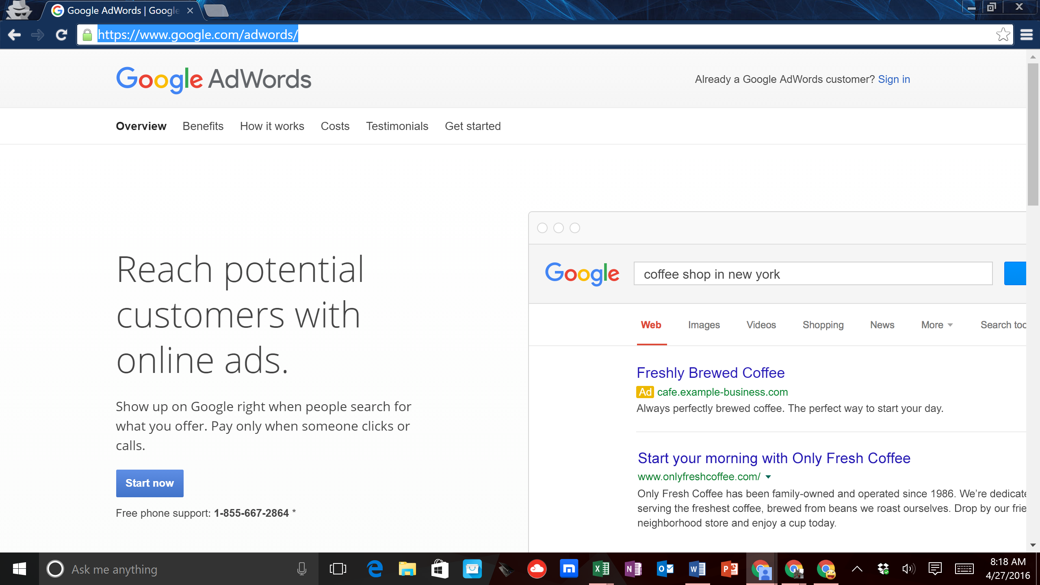

2. Here you should login with the same Login information as your Google Analytics and
Merchant Center accounts.
3. When you log in, you will be prompted to build your 1st campaign
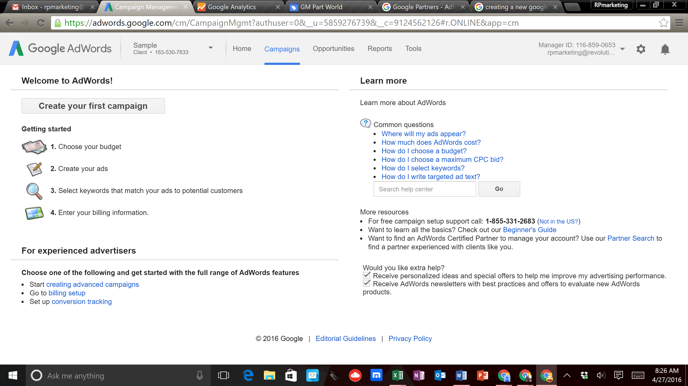

4. Copy the ‘Customer ID’ number and you will paste this code into Google Analytics and the Google Merchant Center
5. Go to Google Analytics and click on the ‘Admin’ tab. Here under the ‘Product’ view click on ‘AdWords’ linking
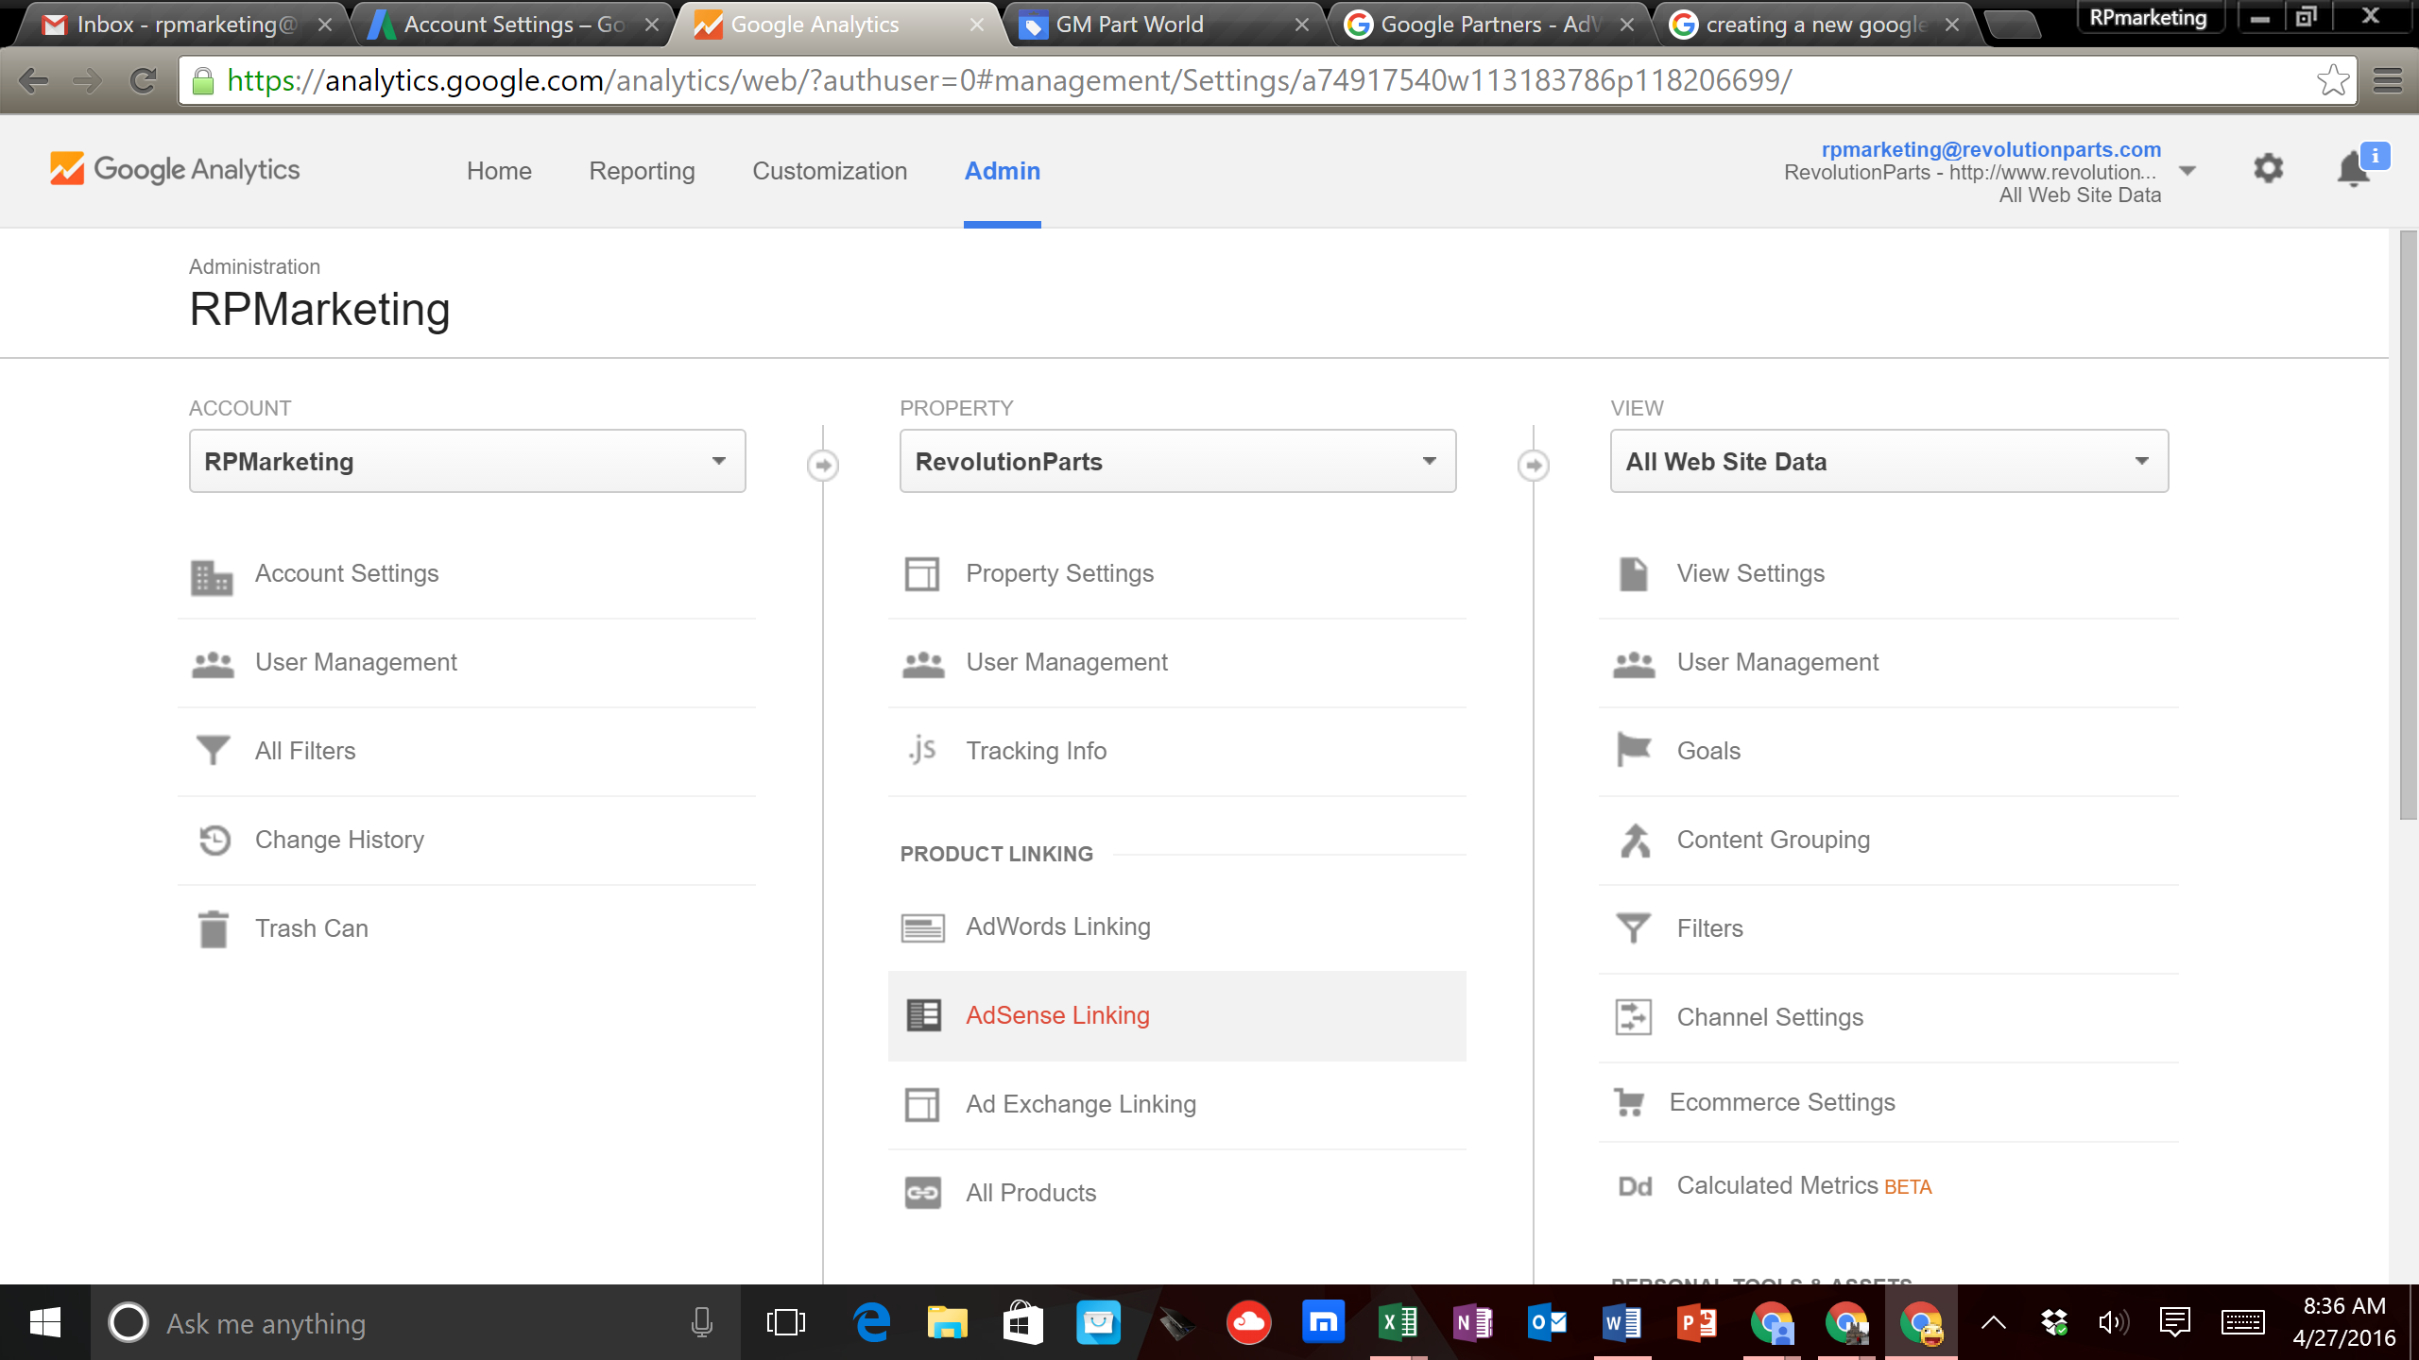

6. Next you will either select an account to link or enter the AdWords customer ID
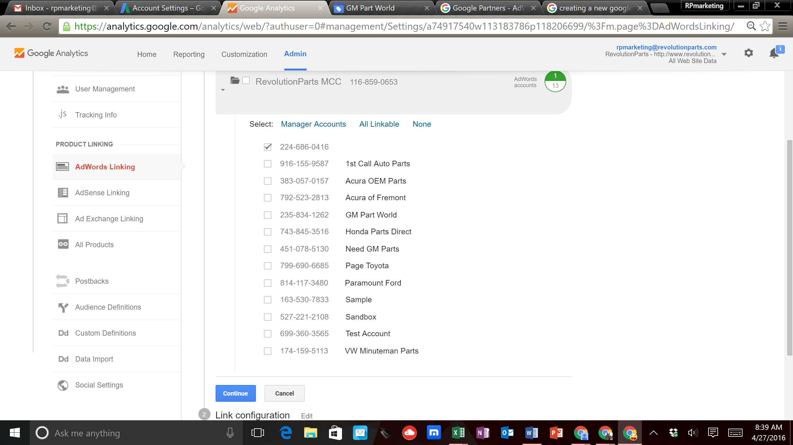
7. Then click ‘Continue’
8. Now on the ‘Link Configuration’ page turn ‘All Website Data On’ then click ‘Link Accounts’
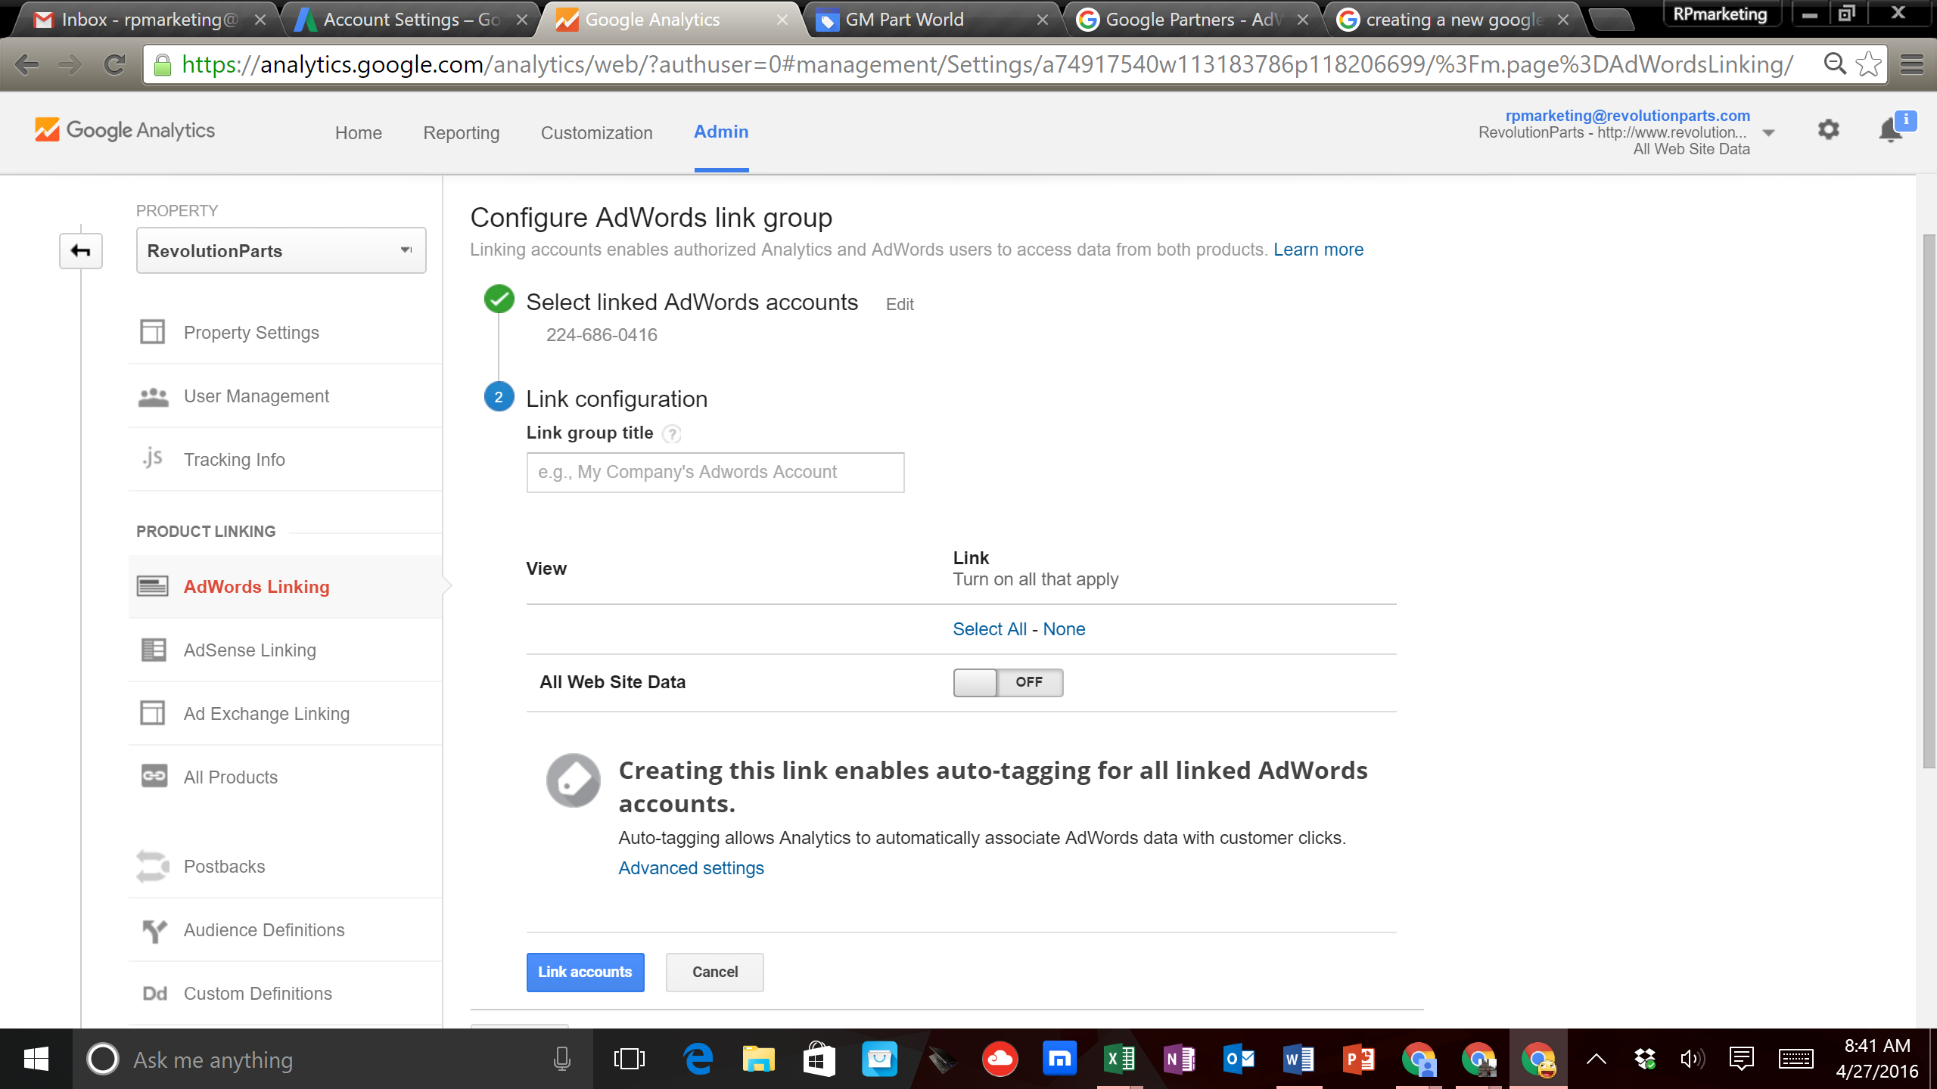

13. Now go back to your Google AdWords Account and click on the ‘Settings’ button
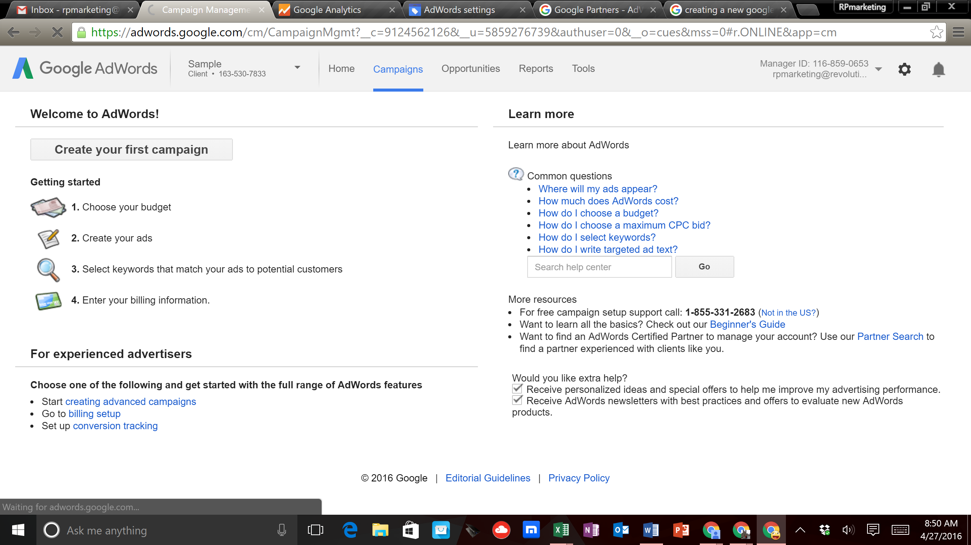

14. From the drop down menu click on ‘Linked Accounts’
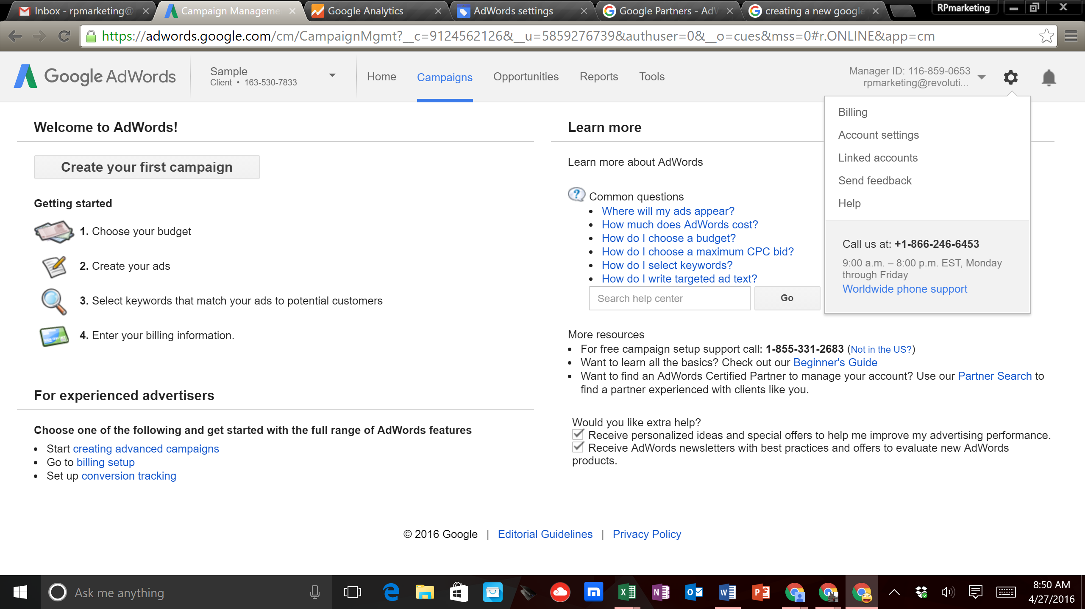

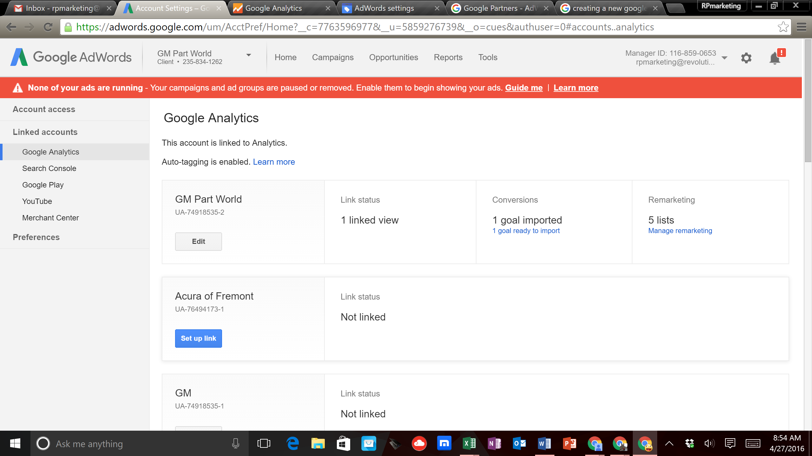

18. Here you will be able to import a ‘Goal’, which in your case will be the transaction information from the Ecommerce Settings that you set up in Google Analytics. Click on the link.
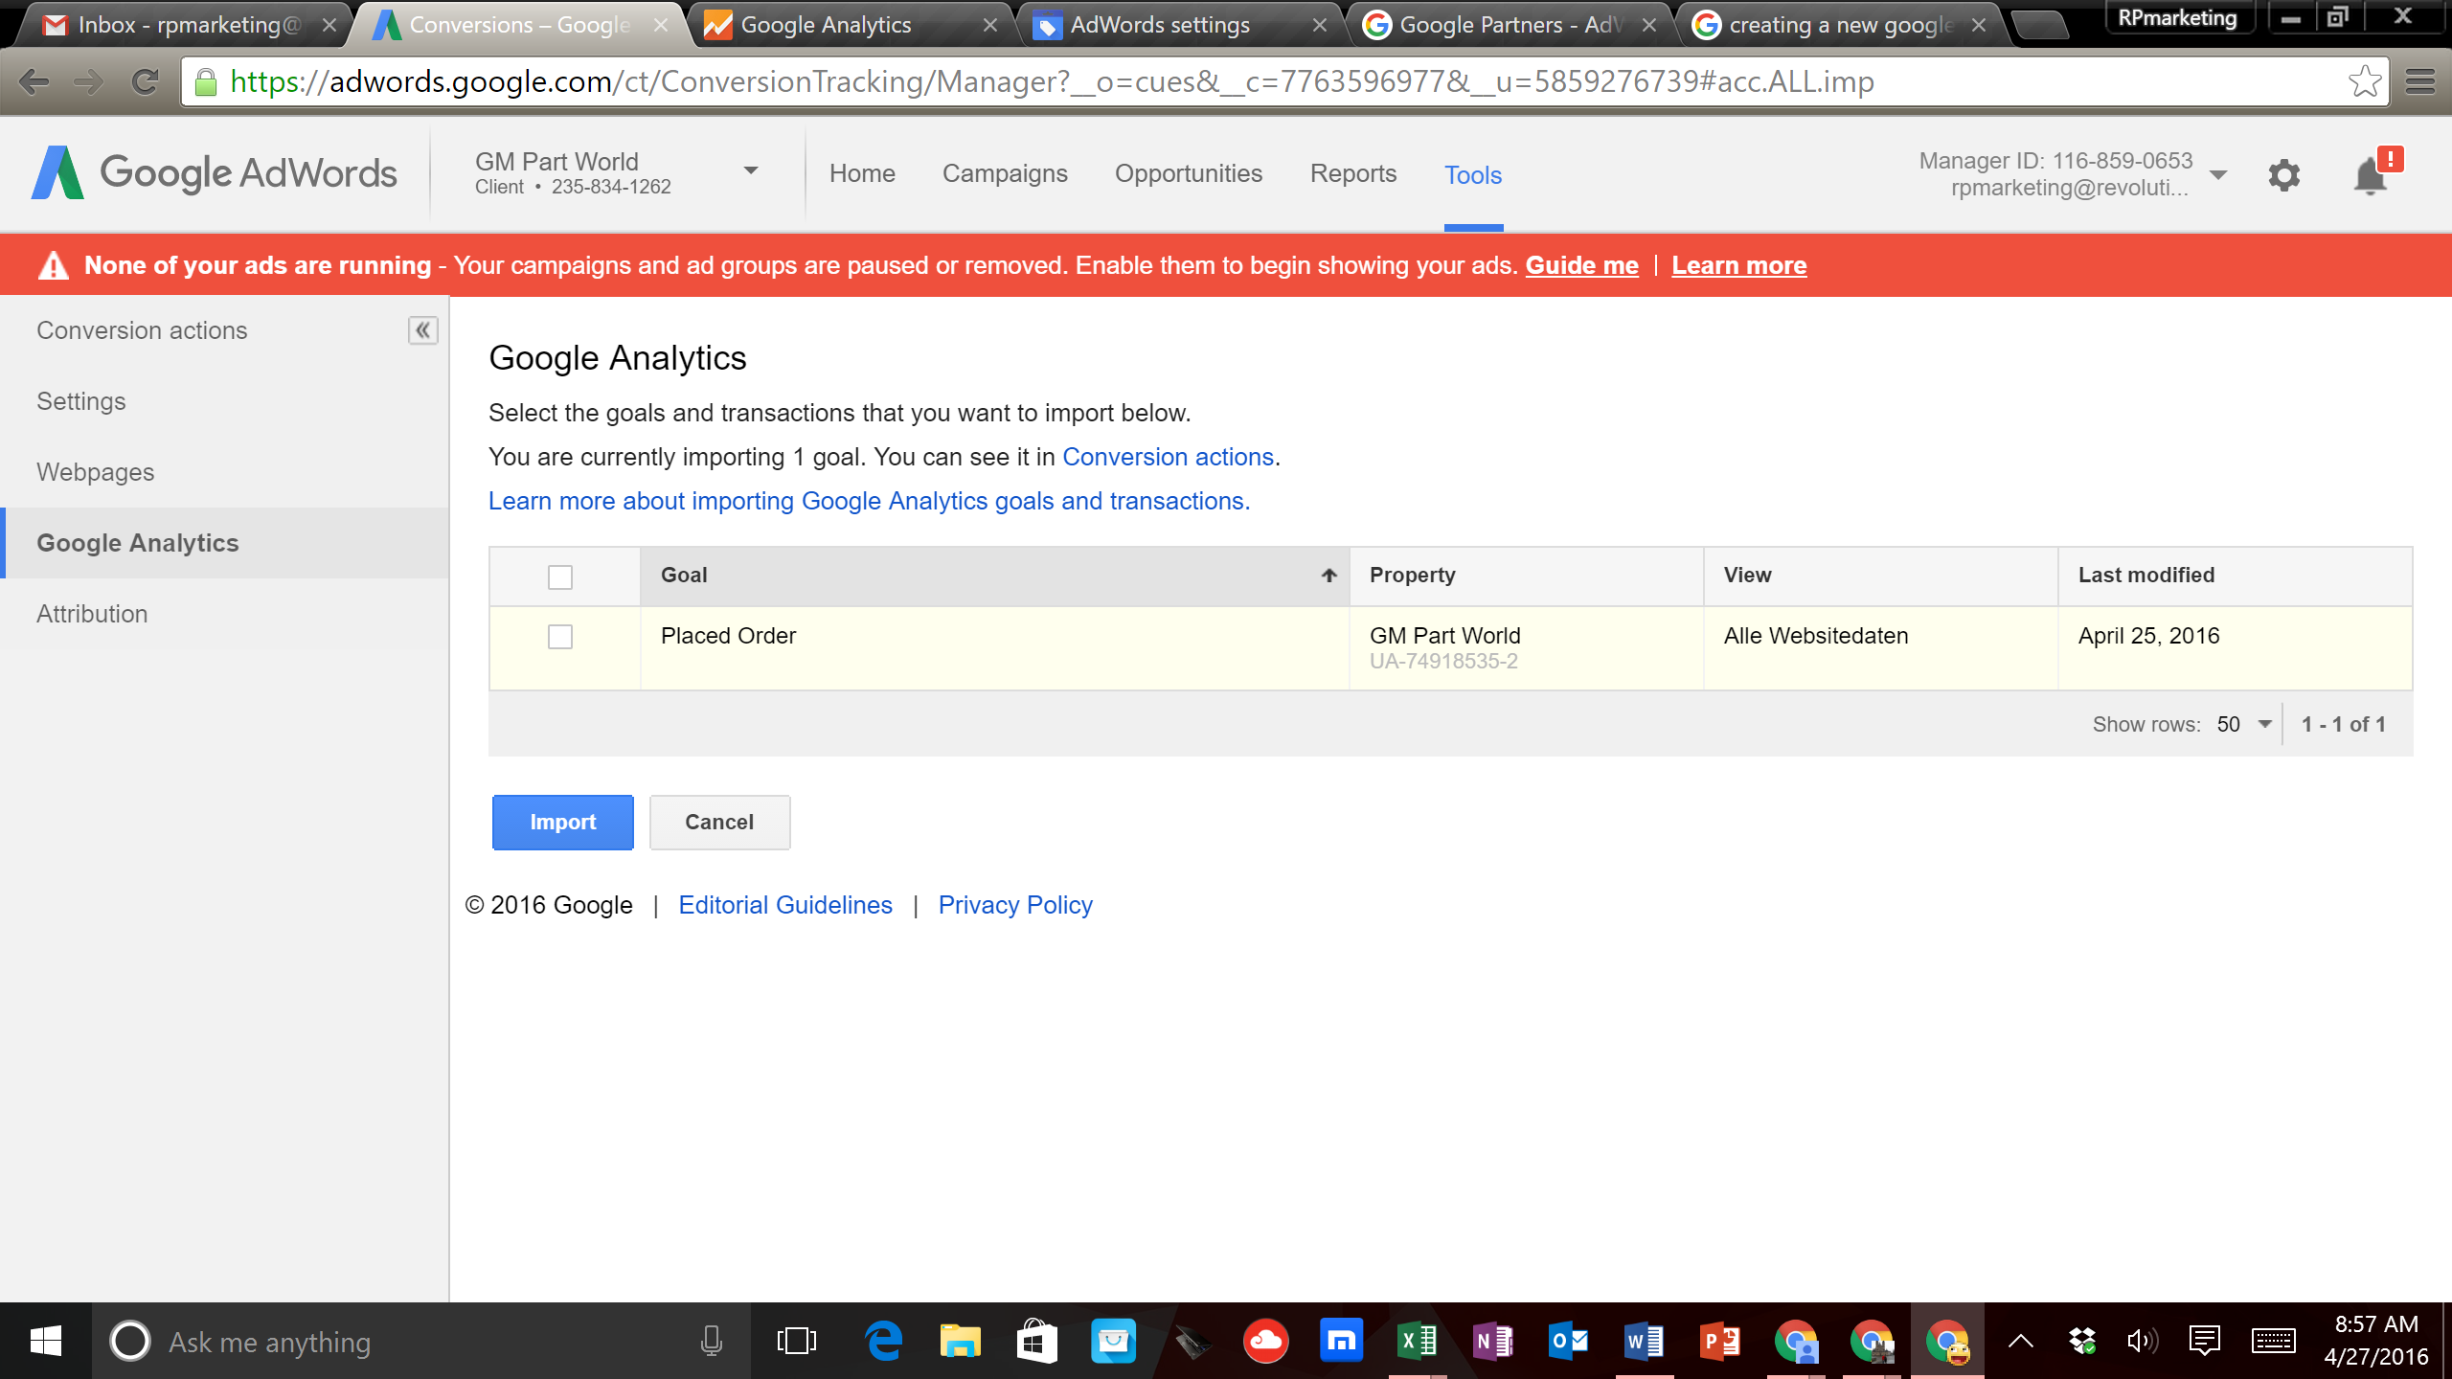

19. Next you will select the goal and then click ‘Import’
20. The screen will look like this:
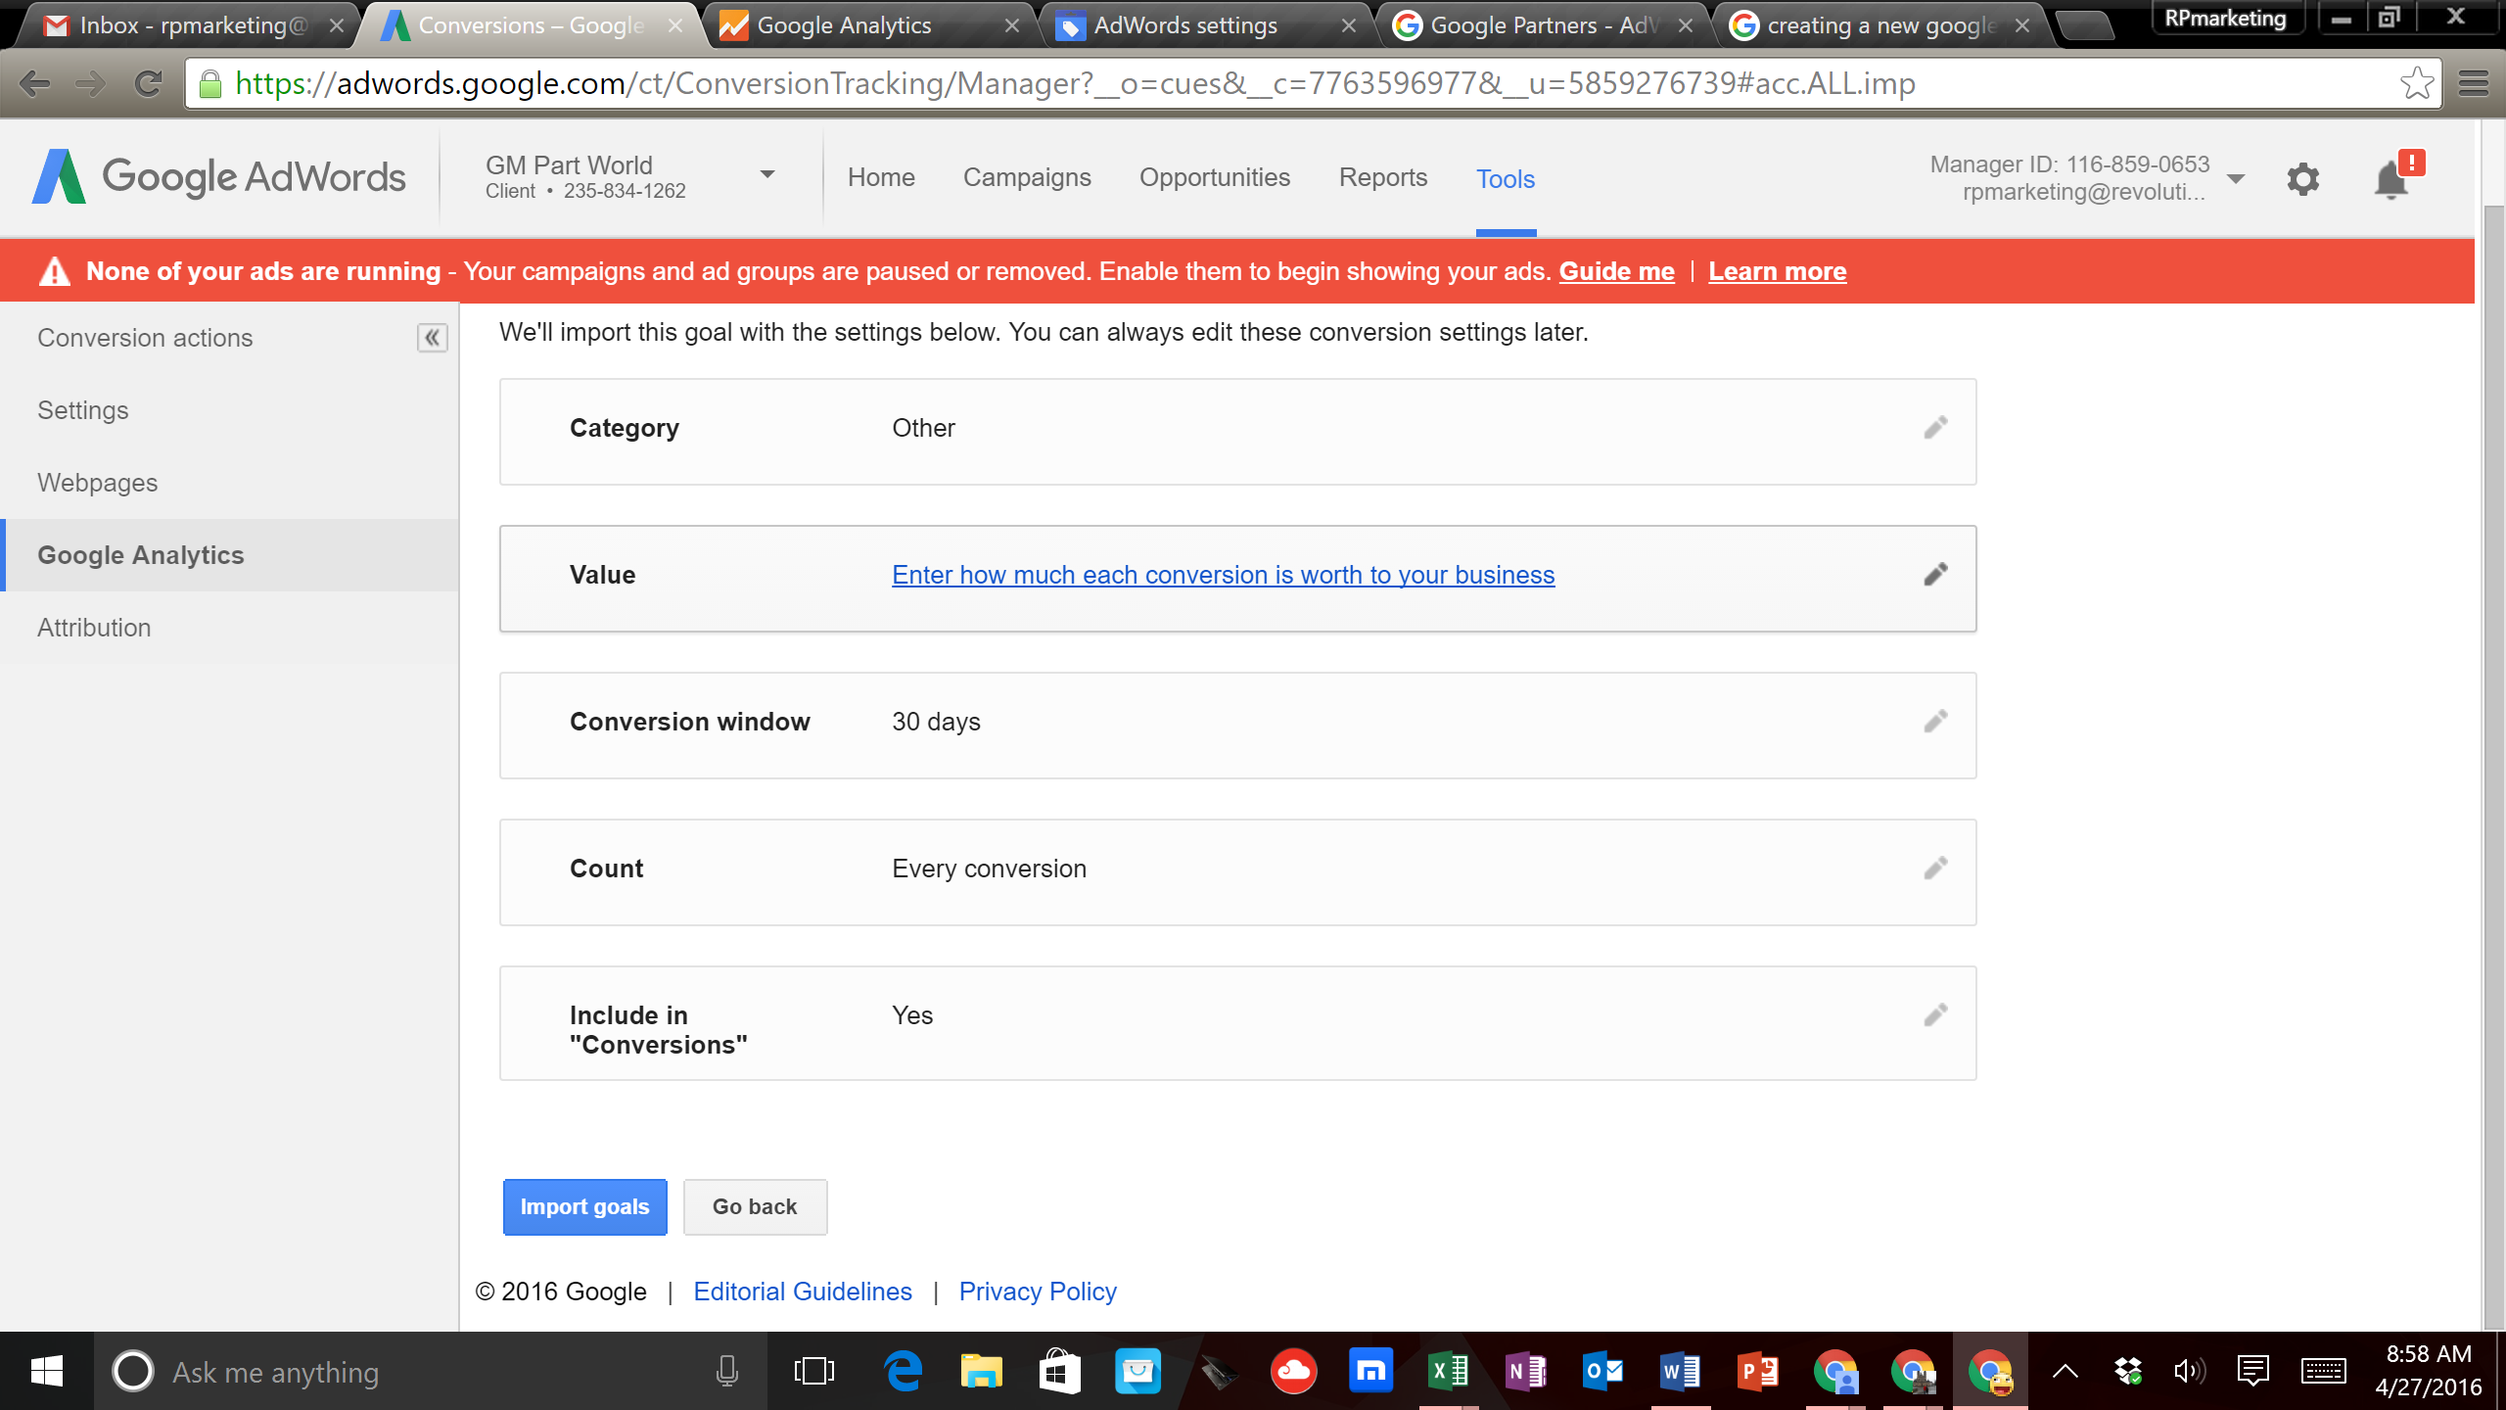

21. Now click on the ‘Category’ section and change the ‘Category’ from ‘Other’ to ‘Sale/Purchase’ and then click ‘Done’
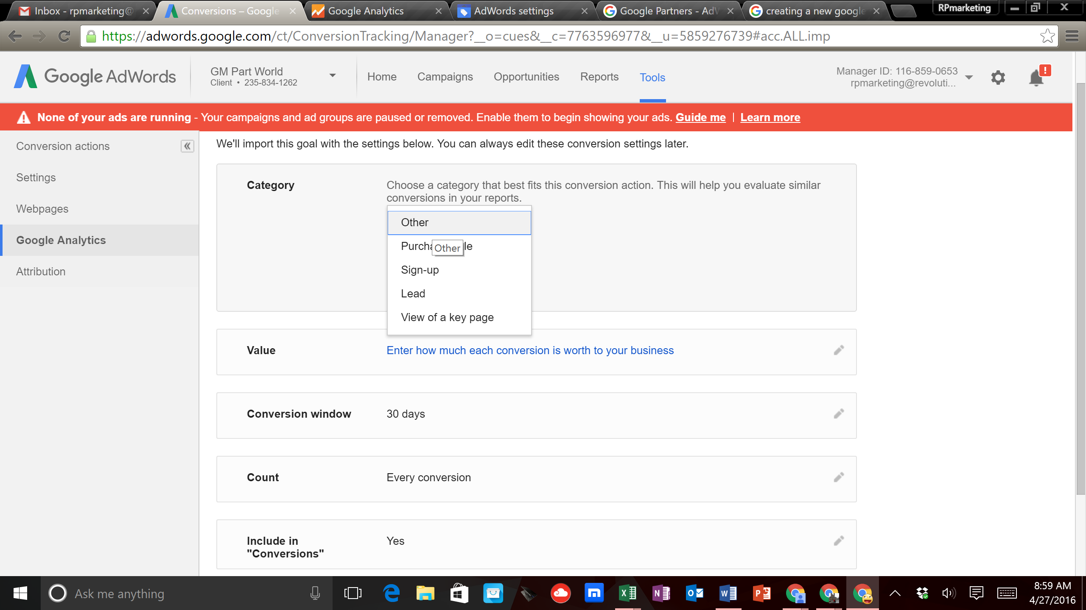

22. Next click on the ‘Value’ section
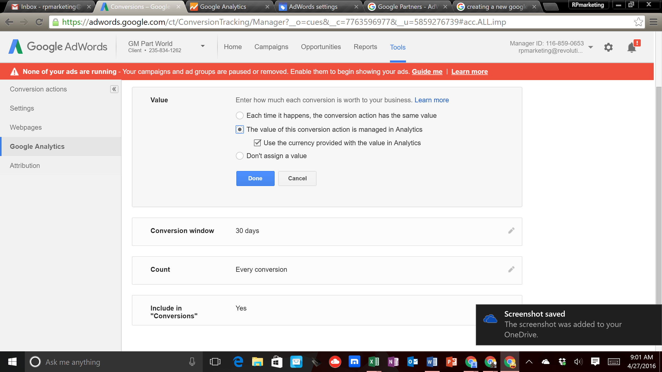

23. Here you will select the ‘The Value of this conversion action is managed in Analytics’ and then click ‘Done’
24. Then click ‘Import Goals’
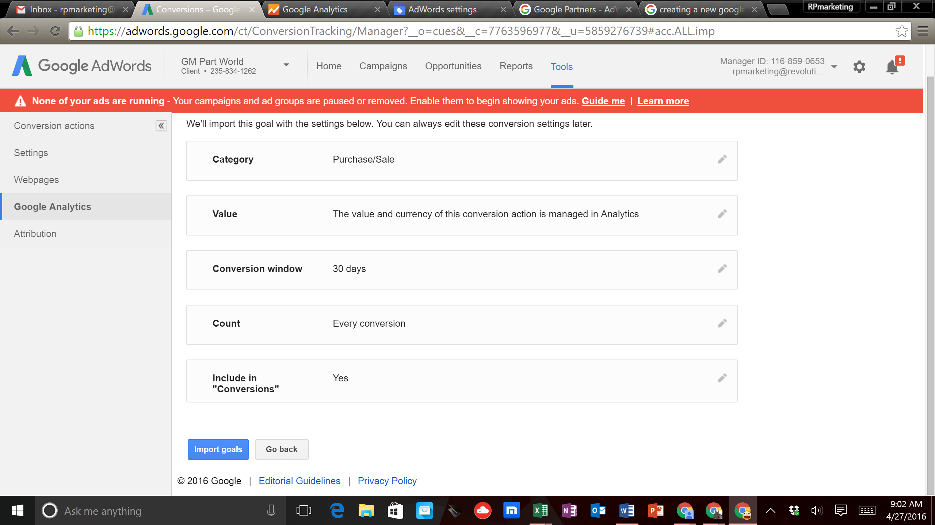

25. Now everything is linked together and you are ready to build your first Shopping Campaign
26. Click on the ‘Campaigns’ tab on the top of the page
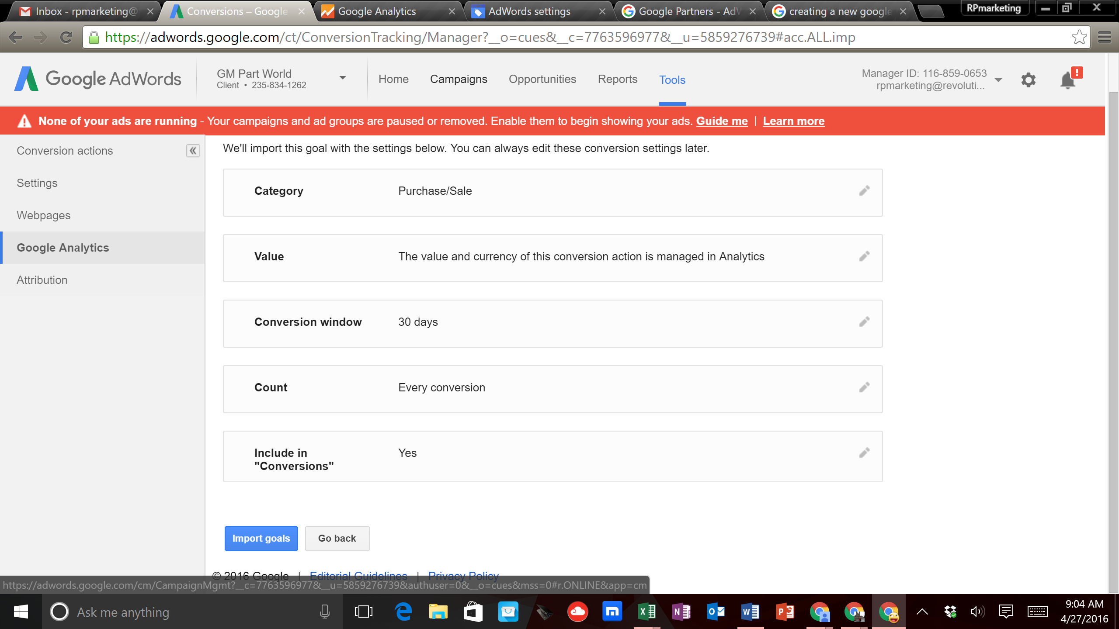

Acquisition and Behavior Tabs
The acquisition tab allows you to see where visitors to your site are coming from. There are numerous ways that people can come to your site, such as paid (AdWords), referral (from another site), social (Facebook, etc), organic, direct (typed in your URL, etc). In this section you are able to see important information that allows you to figure out how many people are coming to your site, how long they are staying on your site, how many pages they are visiting, etc. More specifically, you are also able to see how many transactions and revenue is coming from the different types of traffic. The “Acquisition” tab ties in great with the behavior tab.

The “Behavior” tab allows you to analyze the ‘Landing Page’ people land on when they go to your site. Every page on your website can be a ‘Landing Page’, therefore it is important to have relevant information on your page. For example, if you are running an AdWords campaign and have an ad that emphasizes “Toyota Corolla Parts” you wouldn’t want you visitors going to pages that have “Toyota RAV 4 Parts” or “Toyota Camry Parts” because the content on those pages is not relevant to what they searched for.
An important metric to examine on the ‘Landing Page’ is the ‘Bounce Rate’ which is the percentage of people that only visited one page on your site. If you are running a Google Shopping campaign the ‘Bounce Rate’ could be higher when comparing it to a Google Search campaign because the Shopping page takes you to a very specific page on your site, while the Search campaign requires people to visit more pages on your site to get to the product that they are looking for. Keep in mind that the Auto Parts industry is very competitive so people do a lot of price shopping before they make a purchase.
Finally, the “Behavior” tab also lets you analyze the ‘Exit Page”, which is the last page people were visiting before they left your website. There are many times when the ‘Exit Page’ and the ‘Landing Page’ are the same page, which means that a person only visited one page on your site. Something to examine here is how many people leave the ‘Shopping Cart’ page because many people add products to the shopping cart to see what the total cost of their purchase will be. From here people will either make a purchase or leave your site. Just because a person leaves your site does not mean that they will not purchase from your site. Many people come back at another time to make a purchase. However, if you notice that you are getting a lot of traffic to your site and see either no conversions or very few conversions (conversion rate less than 1%) then your prices (product or shipping costs) may be too high compared to your competitors.

